# **How to Install Nagios Server Monitoring on Ubuntu in AWS**

Nagios is an open source software for system and network monitoring. Nagios can monitor the activity of a host and its services, and provides a warning/alert if something bad happens on the server. Nagios can run on Linux operating systems. At this time, I'm using aws instance of Ubuntu 18.04 for the installation.

And connect to server with password :ubuntu like below

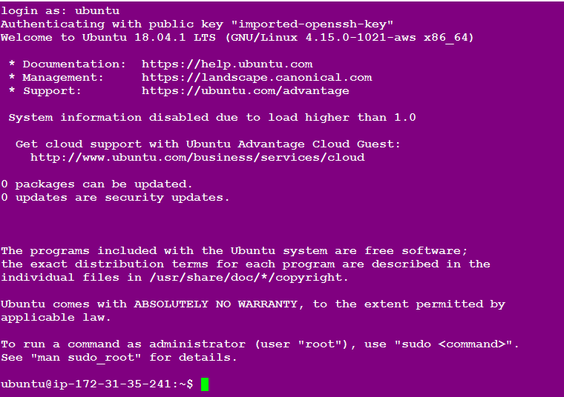

Then provide the root access

$sudo -i



## 

## 

## **Installing the prerequisites**

Nagios requires the gcc compiler and build-essentials for the compilation, LAMP (Apache, PHP, MySQL) for the Nagios web interface and Sendmail to send alerts from the server. To install all those packages, run this command (it's just 1 line):

Before installing the Prerequisites we can update the system

$sudo apt-get update

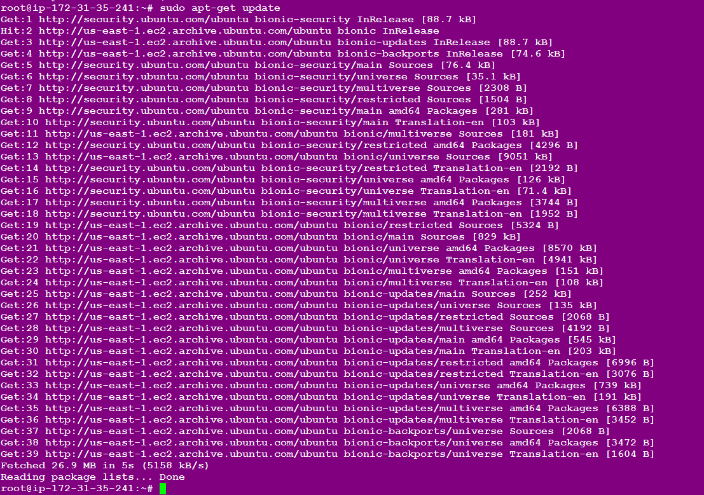

Now we will install required Prerequisites

$ sudo apt-get install -y autoconf gcc libc6 make wget unzip apache2 php libapache2-mod-php7.2 libgd-dev

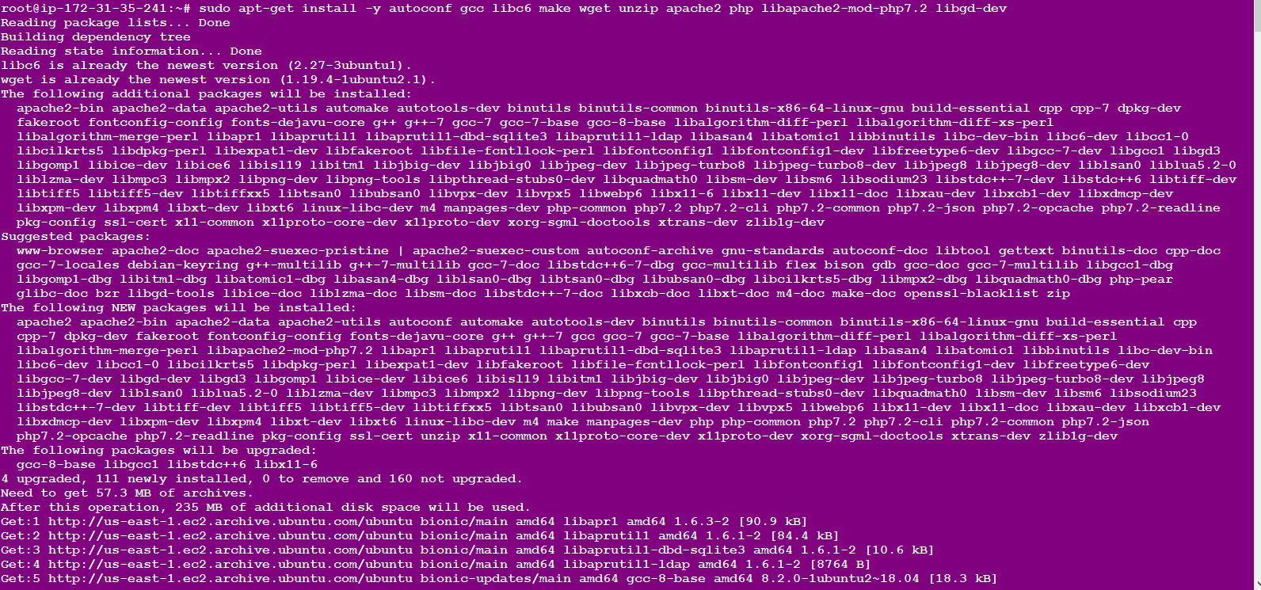

For Nagios to run, you have to create a new user for Nagios. We will name the user **"nagios"** and additionally create a group named **"nagcmd"**. We add the new user to the group as shown below:

$useradd nagios



$groupadd nagcmd



$usermod -a -G nagcmd nagios



$usermod -a -G nagios,nagcmd www-data



### **Downloading the nagios and extract the Nagios core from nagios homepage**

Goto this site and download nagios

<https://www.nagios.org/downloads/>

Here i am creating one Directory name as “nagios” and move to nagios directory and here i am installing Nagios ...its is not mandatory you can download without creating directory also

$mkdir nagios



And changes to nagios directory

$cd nagios



Here i installed nagios latest

$ wget -O nagioscore.tar.gz <https://github.com/NagiosEnterprises/nagioscore/archive/nagios-4.4.3.tar.gz>

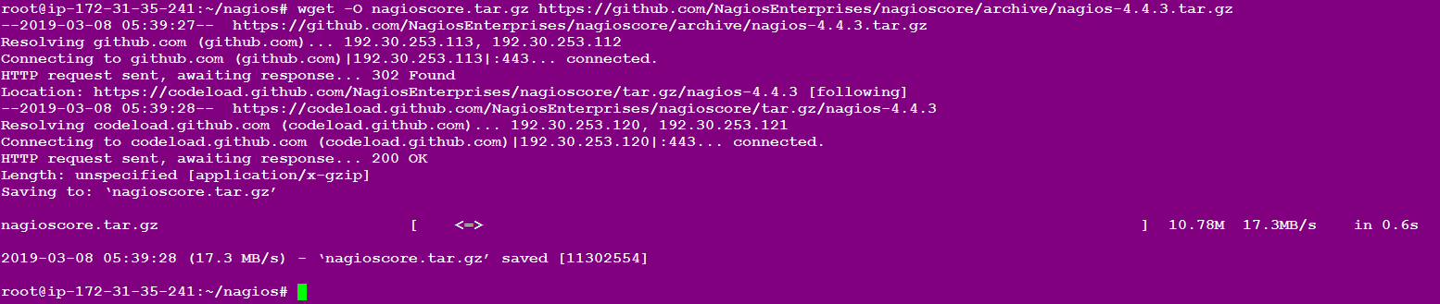

Now extract the file

$tar xzf nagioscore.tar.gz



Now move to that file

$cd nagioscore-nagios-4.4.3/

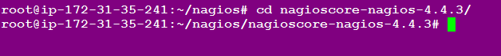

Before you build Nagios,

you will have to configure it with the user and the group you have created earlier

So that we need this command

$./configure --with-nagios-group=nagios --with-command-group=nagcmd

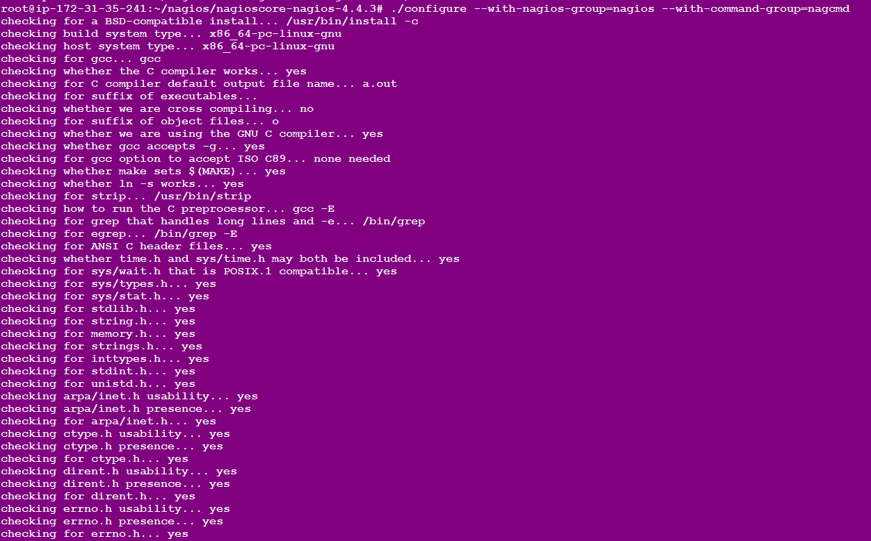

After that we need to Review the options above for accuracy. If they look okay,

type 'make all' to compile the main program and CGIs.

$make all

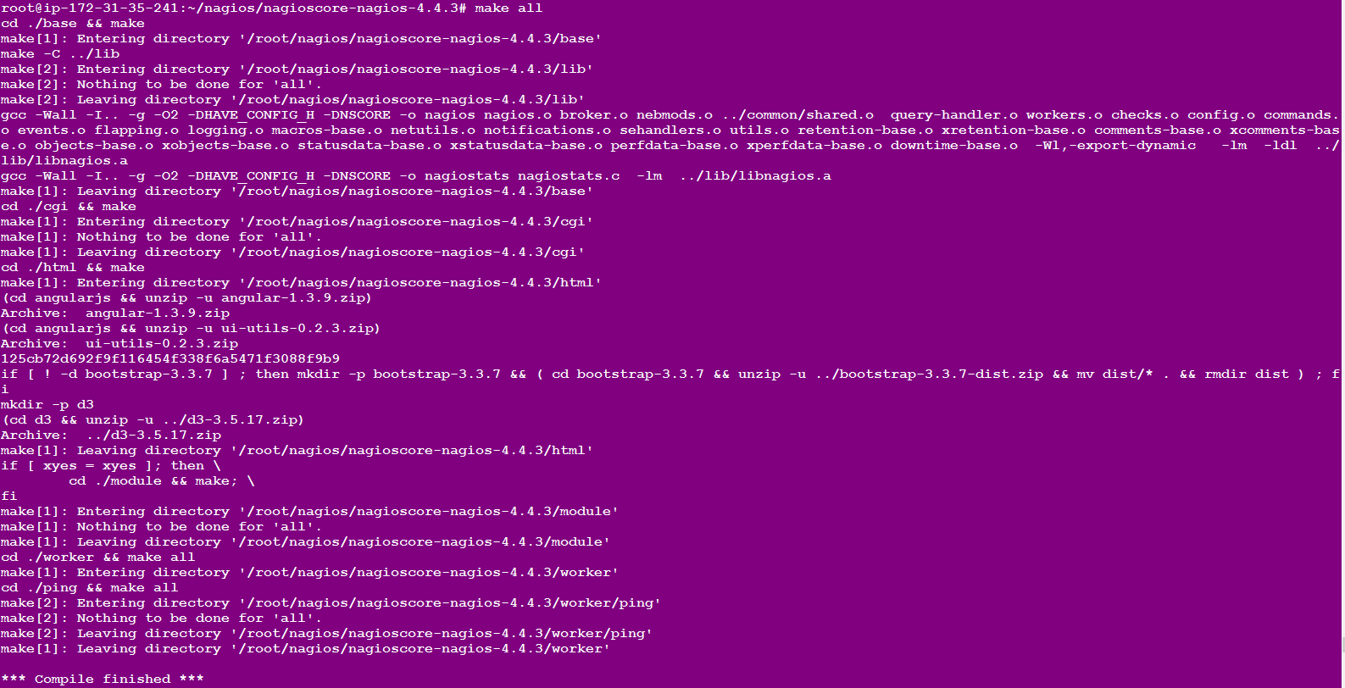

After that we need to install make

$sudo make install

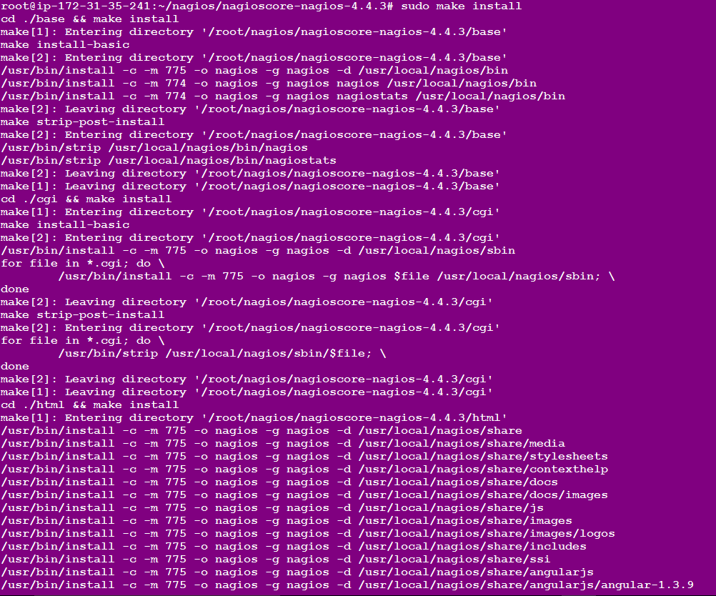

After we installs and configures the external command file.

$sudo make install-commandmode

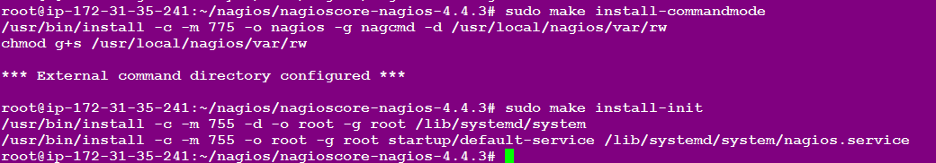

After we installs the service init files and also configures them to start on boot.

$sudo make install-init



After we install Apache config files

$sudo make install-config

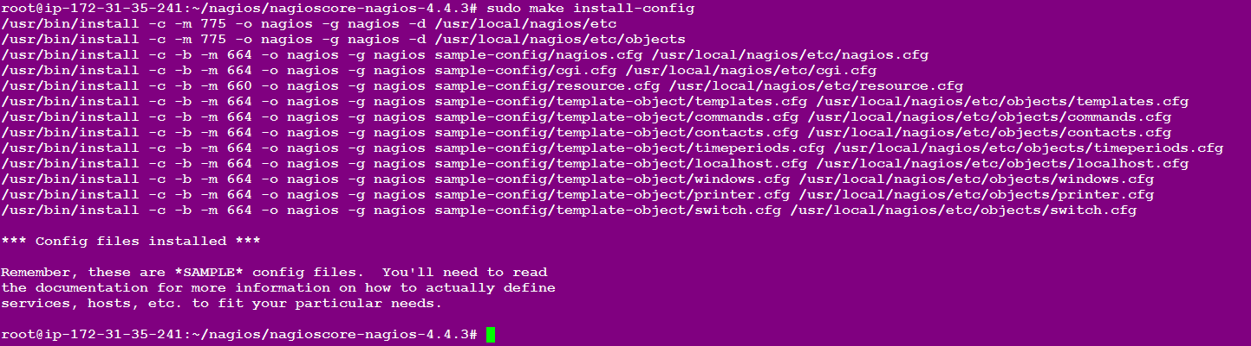

After that we can use this command

$/usr/bin/install -c -m 644 sample-config/httpd.conf /etc/apache2/sites-available/nagios.conf



And now copy evenhandler directory to the nagios directory

$cp -R contrib/eventhandlers/ /usr/local/nagios/libexec/



$chown -R nagios:nagios /usr/local/nagios/libexec/eventhandlers



**Now Install the nagios plugins:-**

Download and extract the Nagios plugins in nagios folder

$cd ..



Now we will Nagios folder ,here download and extract nagios plugins

$wget <https://nagios-plugins.org/download/nagios-plugins-2.1.2.tar.gz>

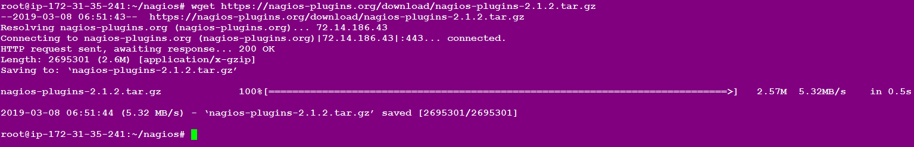

Extract the file

$tar -xzf nagios-plugins*.tar.gz



Changed to nagios plugins folder

$cd nagios-plugins-2.1.2/



Install the Nagios plugin's with the commands below

$./configure --with-nagios-user=nagios --with-nagios-group=nagios --with-openssl

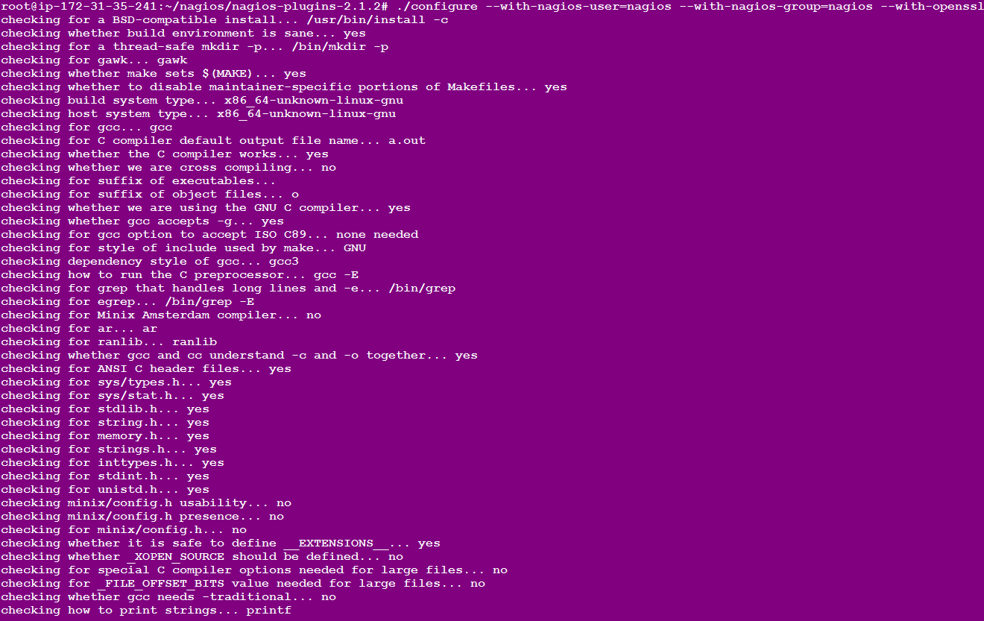

And now we install make command

$make

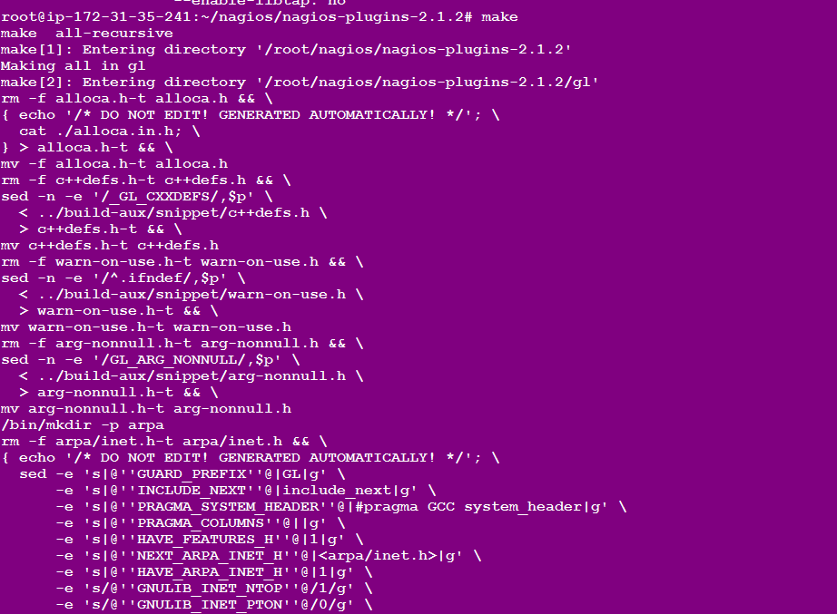

$make install

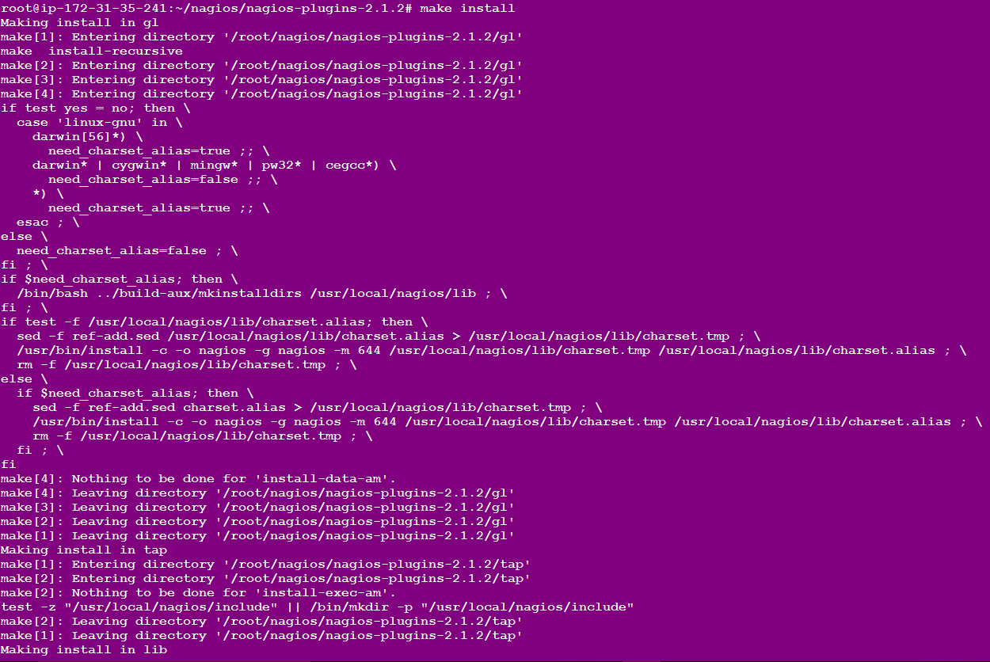

After the installation phase is complete, you can find the default configuration of Nagios in */usr/local/nagios/*.

We will configure Nagios and Nagios contact.Edit default nagios configuration with vi

$vi /usr/local/nagios/etc/nagios.cfg

uncomment line **51st line**  for the host monitor configuration. Like below and save it

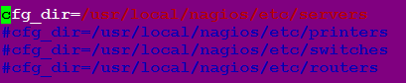

Add a new folder named *servers*:

$mkdir -p /usr/local/nagios/etc/servers



The Nagios contact can be configured in the *contact.cfg* file. To open it and add your email and save and exit

$vi /usr/local/nagios/etc/objects/contacts.cfg

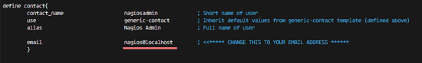

In the red mark place remove that and add your email id and save it

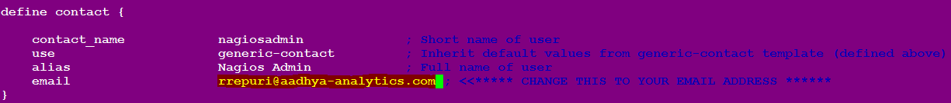

**NOW configuring the Apache**

**1.now enable the apache modules**

$sudo a2enmod rewrite

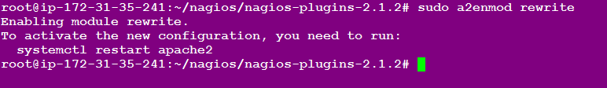

$sudo a2enmod cgi

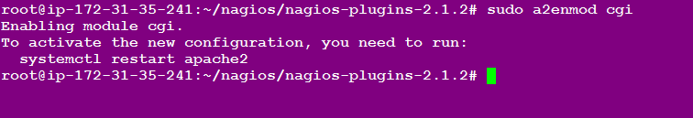

After that You can use the *htpasswd* command to configure a user *nagiosadmin* for the nagios web interface

$sudo htpasswd -c /usr/local/nagios/etc/htpasswd.users nagiosadmin

When ever use this command it will ask the password for nagios home page

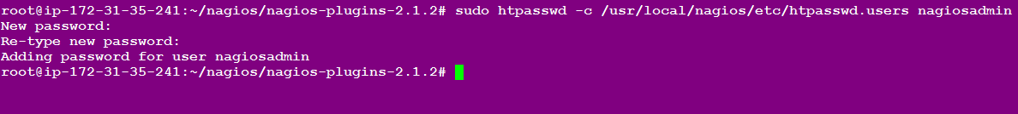

**2.Now enable the nagios host:-**

$sudo ln -s /etc/apache2/sites-available/nagios.conf /etc/apache2/sites-enabled/



**3.Start the apache nagios ::**

$service apache2 restart



$service nagios start



## **Testing the Nagios Server**

First check the Security Group port numbers and provide the all traffic

Please open your browser and access the Nagios server publicip, in my case: 35.175.253.177***/nagios***.

Nagios Login with apache htpasswd.

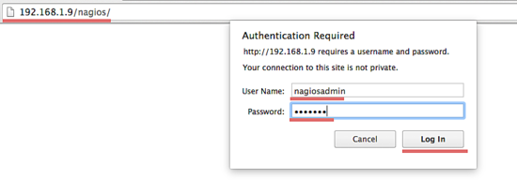

Nagios Admin Dashboard

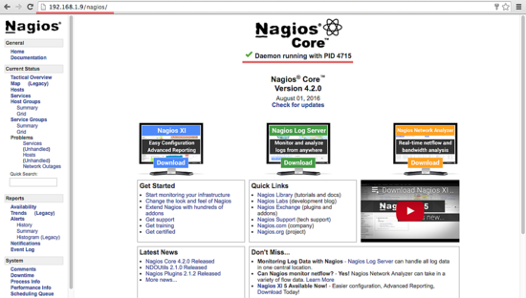

THANK YOU